**PRACTICAL 2**

Steps for How to Start Project:

|  |  |
| --- | --- |
|  | Ionic start project_name |
| **2.** | import new template named as – “Tutorial” --type=ionic-angular |
| **3.** | ionic start MyFirstApp Tutorial --type=ionic-angular |
| **4.** | Open your folder in CMD by using cd (folder name)  now type “ionic serve” in CMD |
| **5.** | now open (visual studio application  To add new page in ionic project command - “ionic g pages about” |
| **6.** | open the project folder that you had created |
| **7.** | In visual studio application open  SRC>APP>APP.COMPONENT.TS>APP.MODULE.TS |
| **8.** | Now open Pages file in visual studio application/ new CMD window and then open - APP.MODULE.TS folder  You will see many code of lines. |
| **9.** | Write this command - import { AboutPage } from '../pages/about/about';  In below of the other page on 9th line of the APP.MODULE.TS page. |
| **10.** | Now open APP.COMPONENT.TS folder and type this command –  import { AboutPage } from '../pages/about/about'; |
| **11.** | In the APP.MODULE.TS page go to the the “@NgModule Part” (i.e line no 14 of APP.MODULE.TS page) and below the “ ListPage ” type AboutPage |
| **12.** | In the APP.MODULE.TS page go to the the “bootstrap : [Ionic App]”(i.e line no 26 of APP.MODULE.TS page) and below the “ ListPage ” type AboutPage |
| **13.** | . In the APP.COMPONENT.TS page go to the “this.pages” part (i.e. line no 32 of APP.COMPONENT.TS page) and below  “title: 'My First List', component: ListPage”  type title: 'AboutUs', component: AboutPage |
| **14.** | Save all the files |

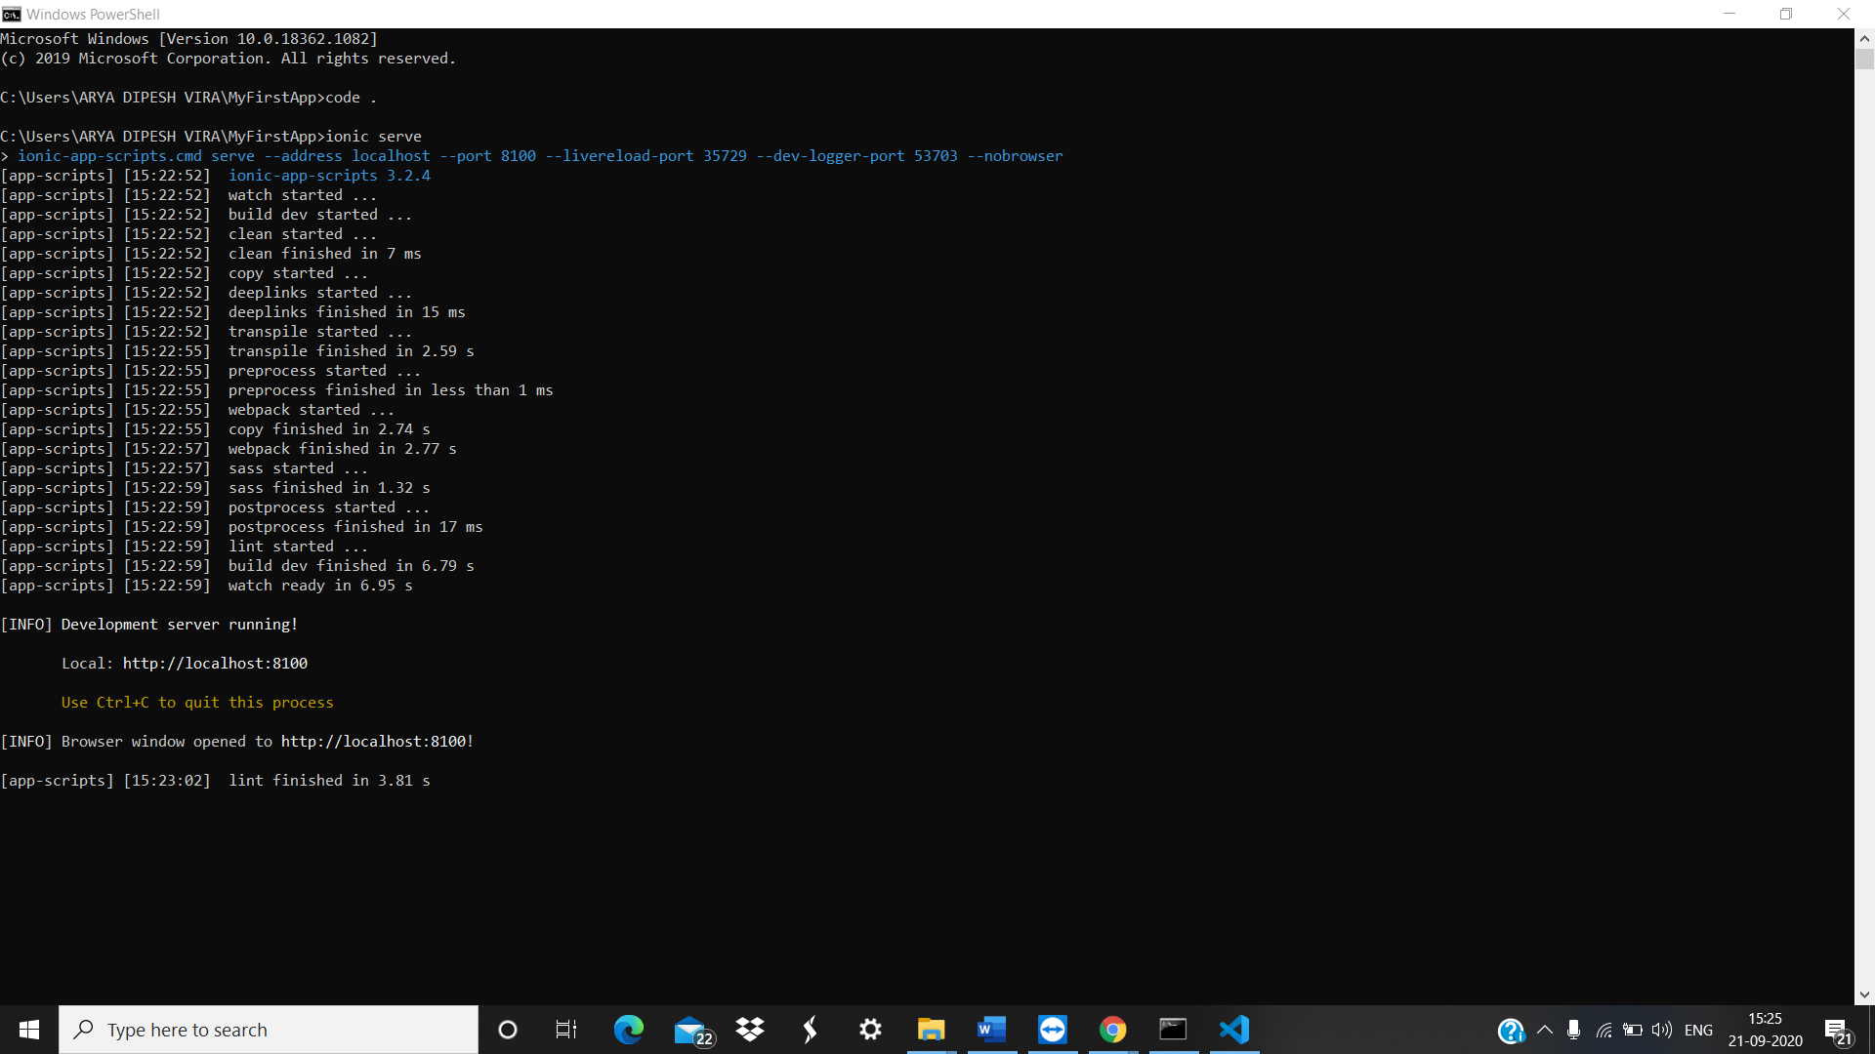Code:

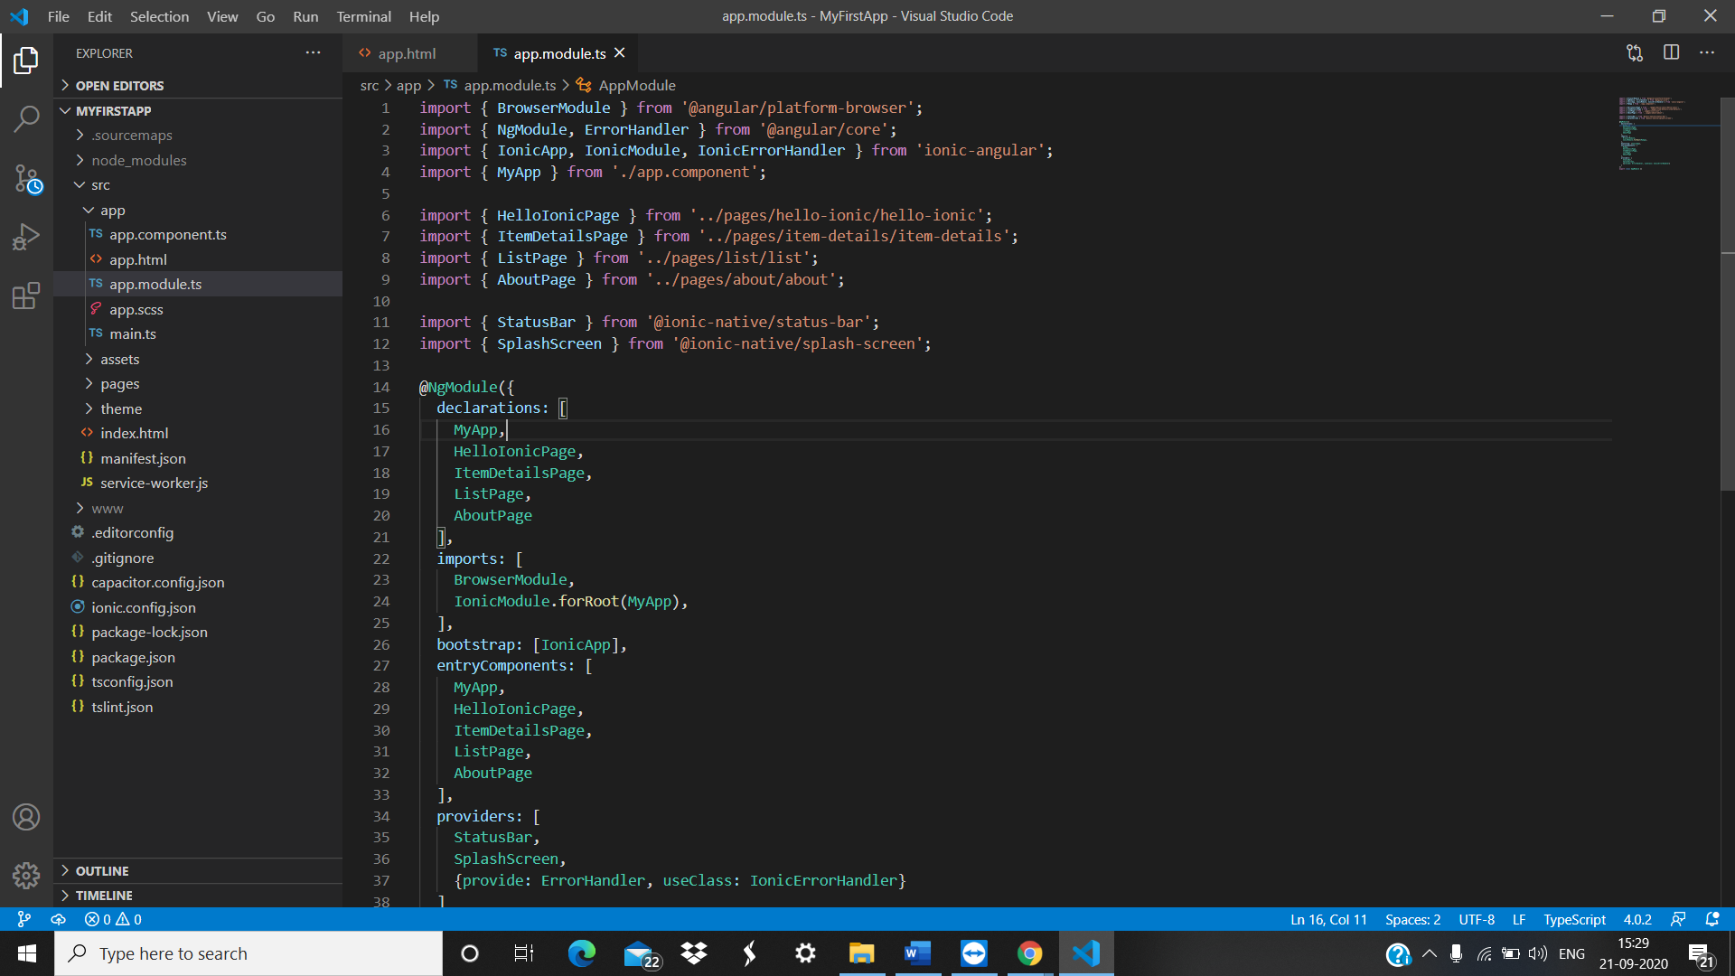

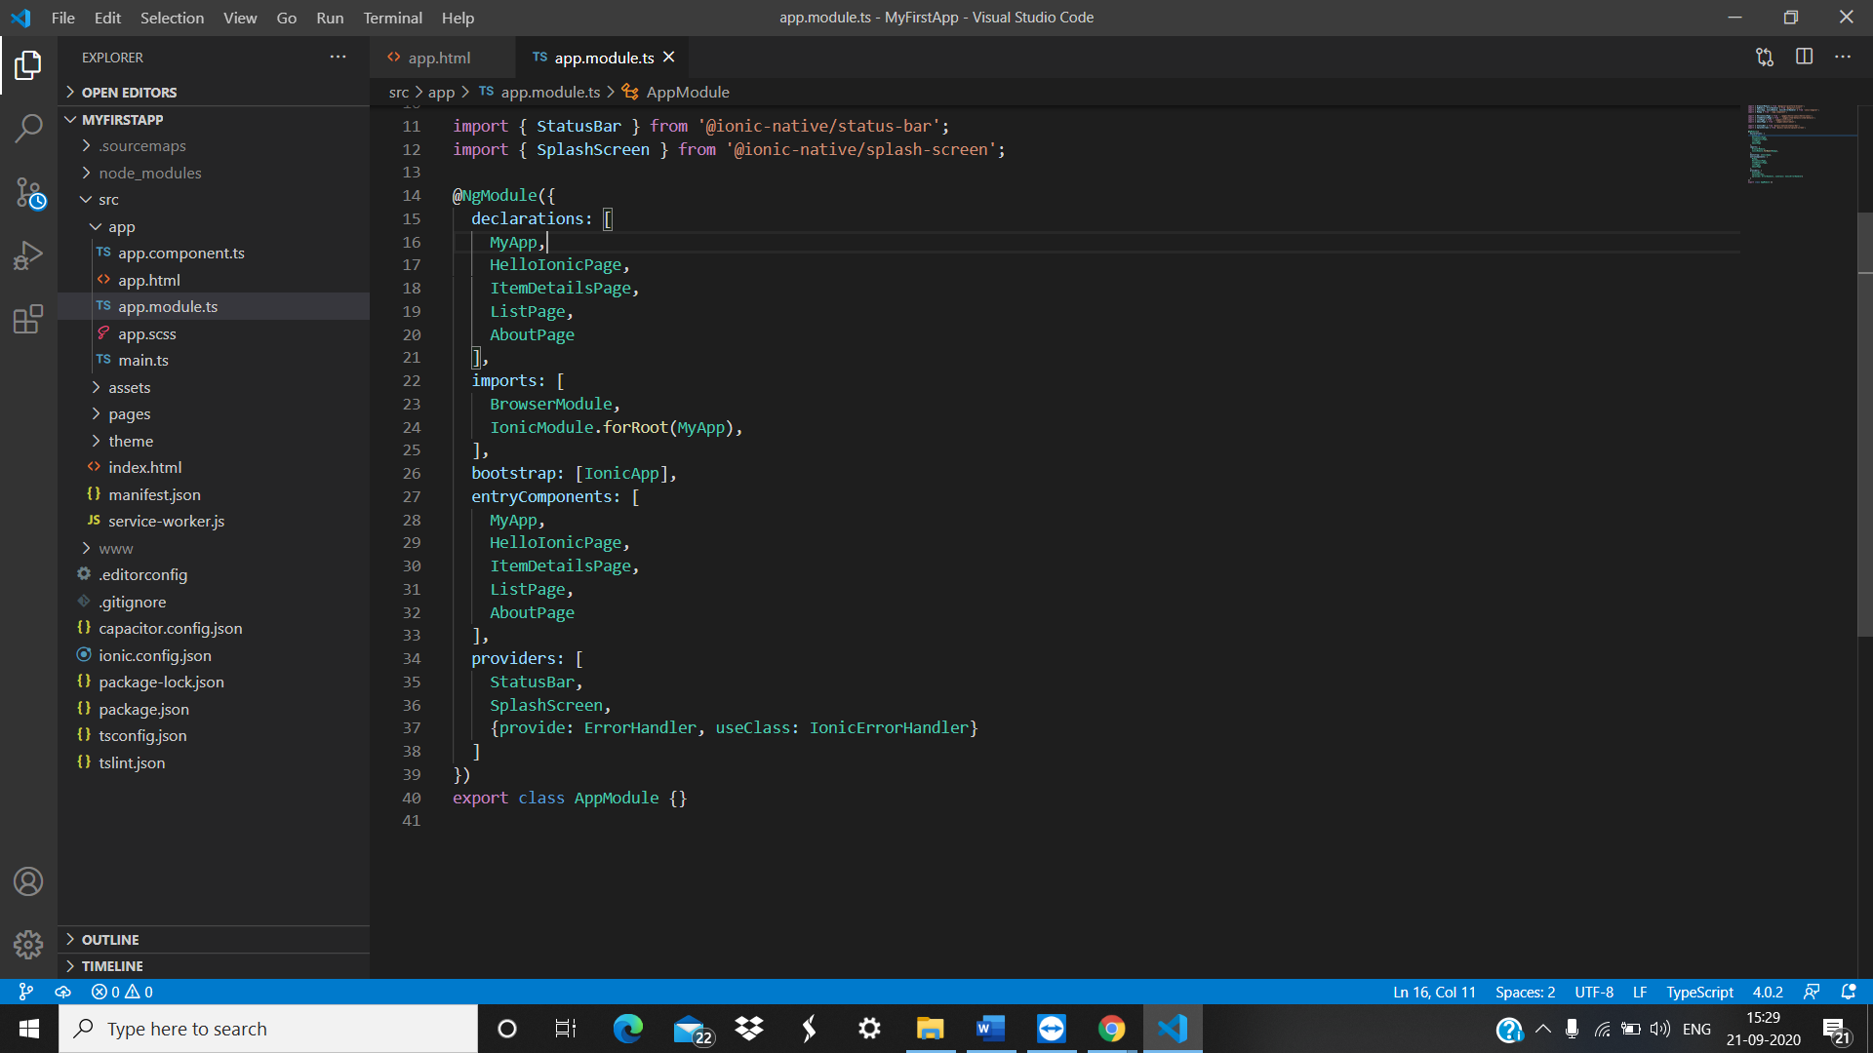

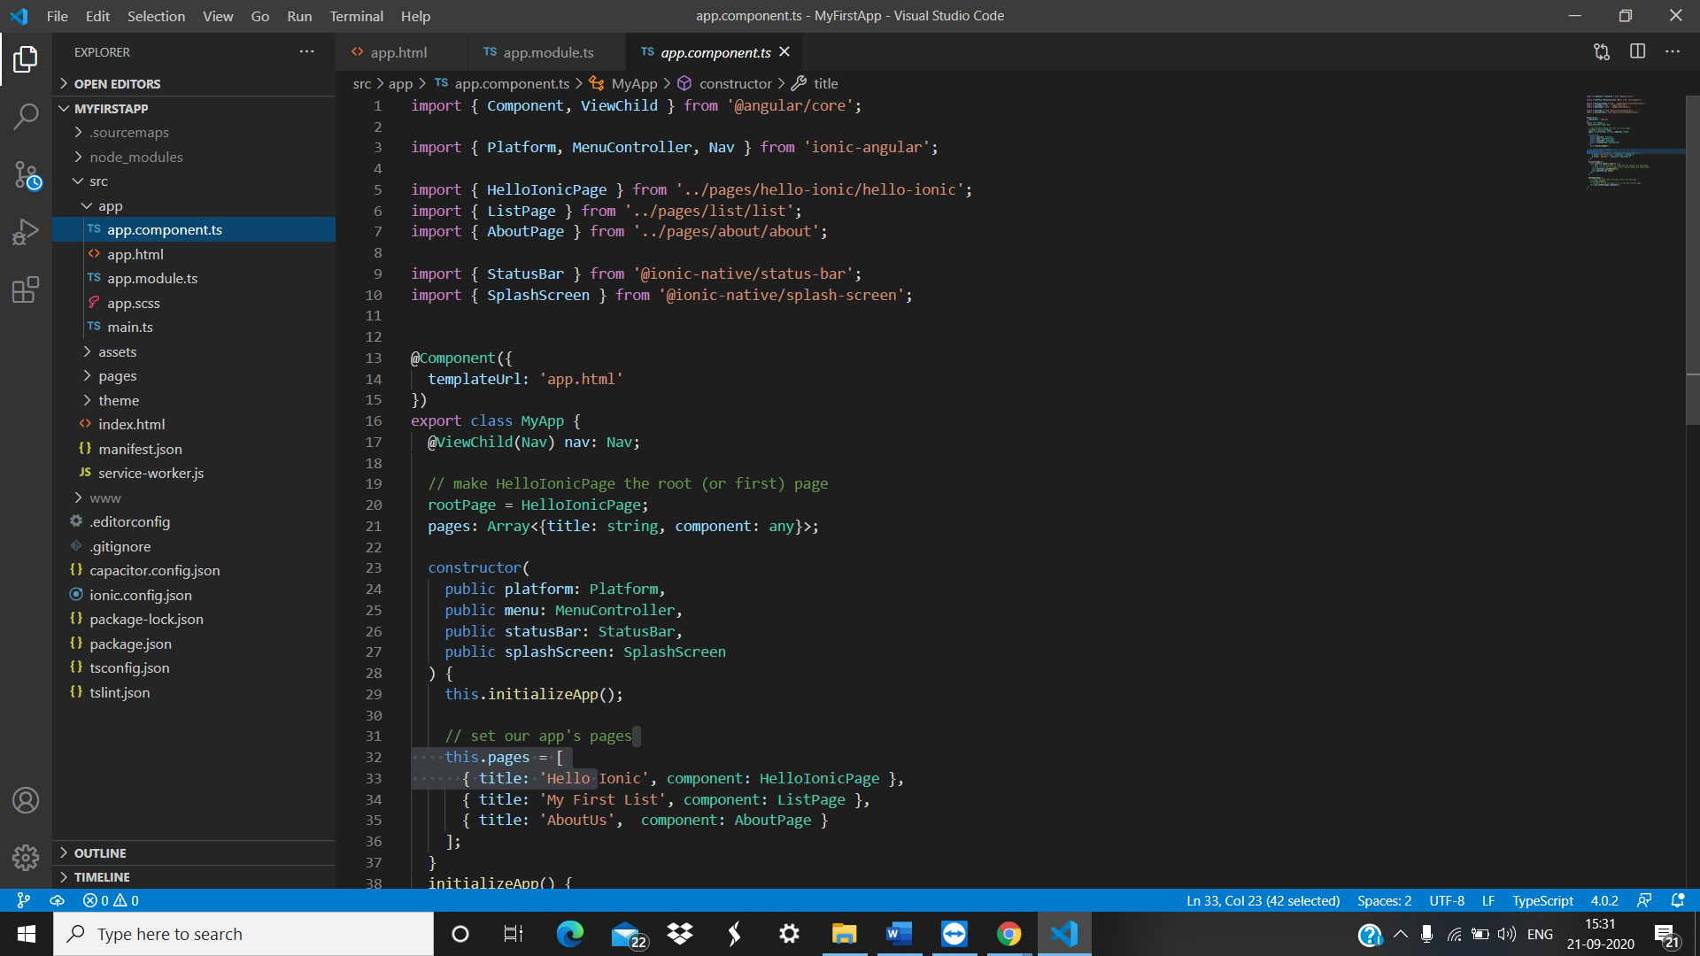

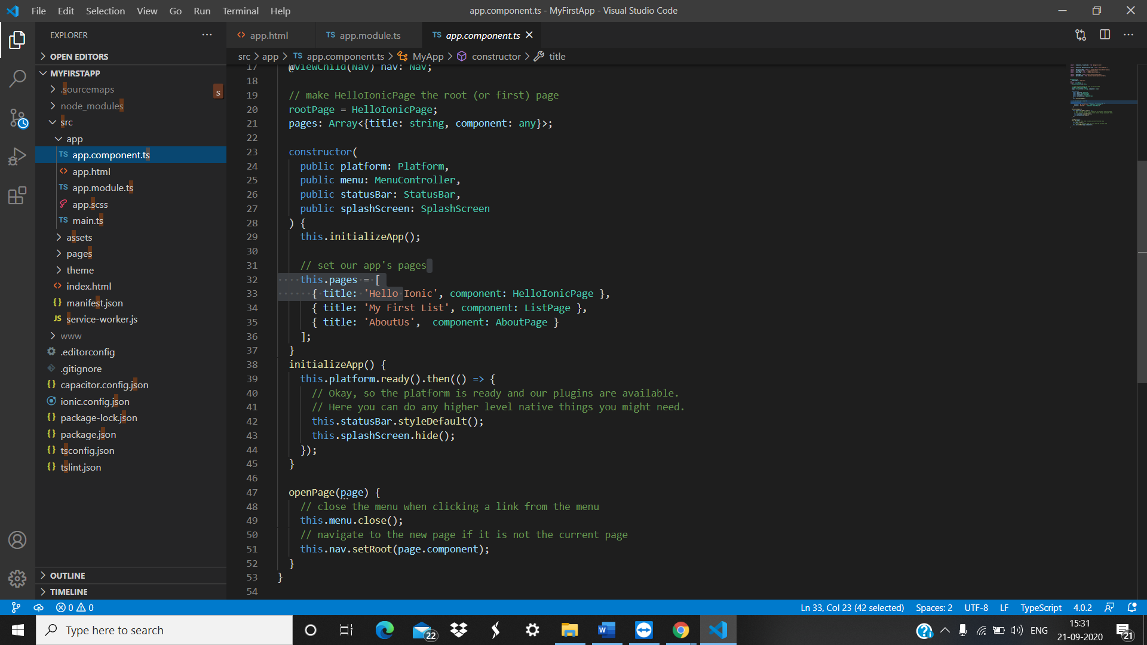

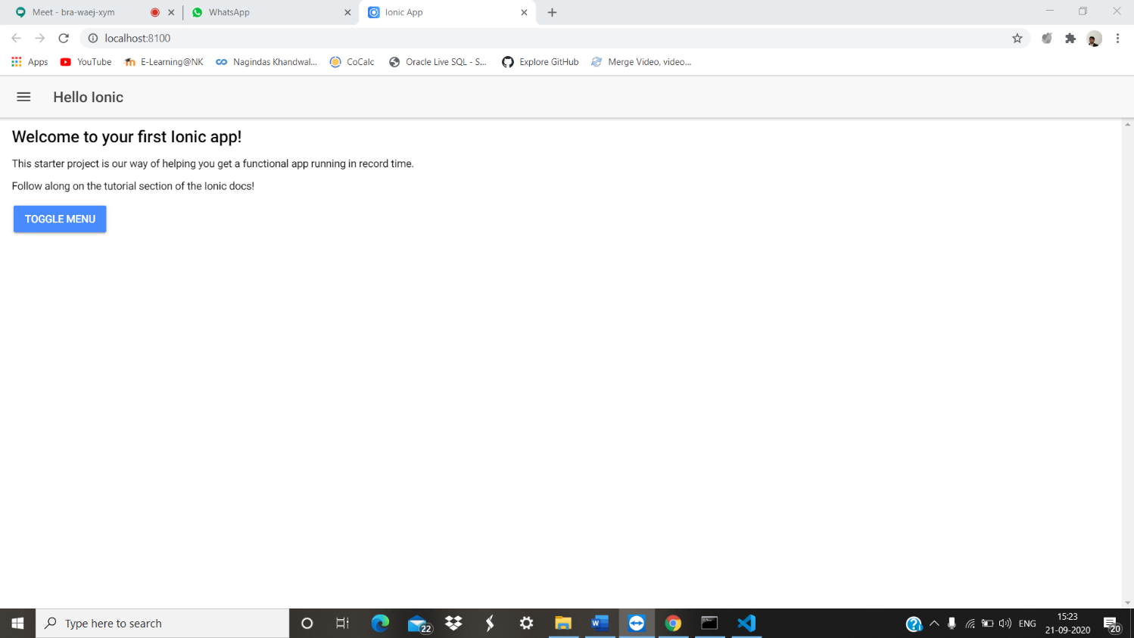Output:

